**Cycle-1**

1. Print your name to the screen with every letter being a different heading size
2. Display the following text:

H2O

12th April 2016

HTML stands for ~~High Text Markup Language~~

He said <**I am fine**>

1. Print a paragraph with 4 - 5 sentences. Each sentence should be a different font.
2. Print a paragraph that is a description of a book, include the title of the book as well as its author. Names and titles should be underlined, adjectives should be italicized and bolded
3. Print two lists with any information you want. One list should be an ordered list, the other list should be an unordered list.
4. Prints 10 names with a line break between each name. The list should be alphabetized, and to do this place a subscripted number next to each name based on where it will go in the alphabetized list. (Example: Alan1). Print first, the unalphabetized list with a subscript number next to each name, then the alphabetized list. Both lists should have an <h1> level heading

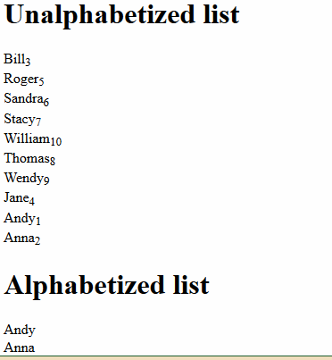

1. Print the squares of the numbers 1 - 20. Each number should be on a separate line, next to it the number 2 superscripted, an equal sign and the result

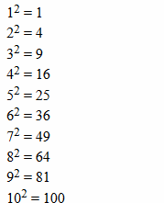

1. Print a definition list with 5 items.
2. Display an image that has a border of size 2, a width of 200, and a height of 200.
3. Print ten acronyms and abbreviations of your choosing, each separated by two lines. Specify the data that the abbreviations and acronyms represent

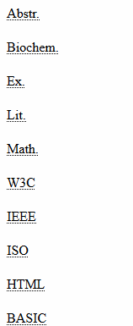

1. Print two addresses in the same format used on the front of envelopes (senders address in top left corner, receivers address in the center

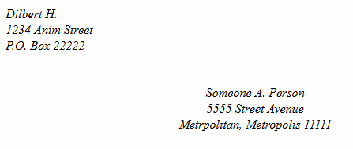

1. Create an HTML page with the following contents:

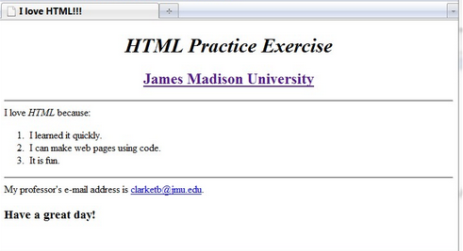

1. Create the following table

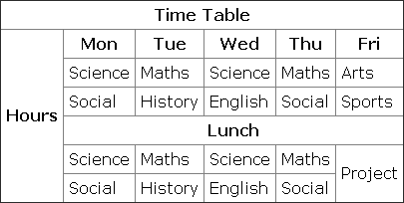

1. Create a HTML Page which looks like the one given below

